**COMPUTER PROGRAMMING**

**ASSIGNMENT NO#03**

**GROUP MEMBERS:**

**IQRA HAFEEZ**

**01-131232-036**

**AYESHA ARSHAD**

**01-131232-044**

**CLASS:**

**BSE 1B**

**TASK NO 1:**

**CODE IN CPP:**

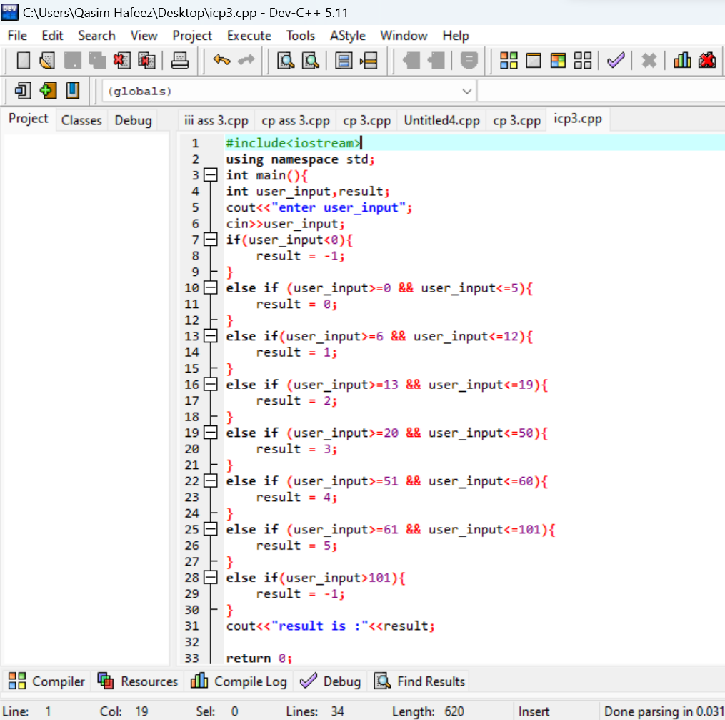

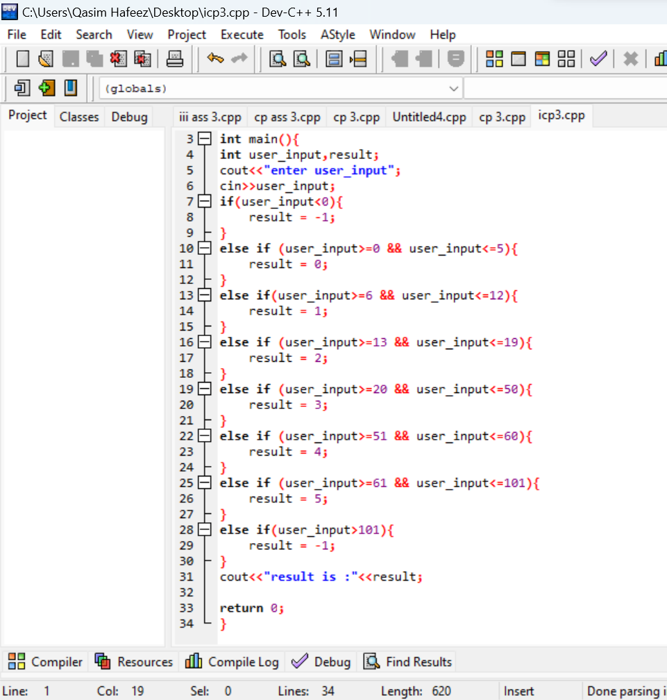

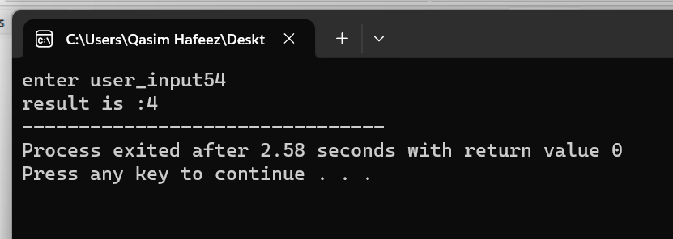

**TASK NO #O2**

**ALGORITHM:**

Step 1: Start.

Step 2: Declare 'user_input' and 'result’.

Step 3: Take 'user_input' from the user.

Step 4: Create if else statement.

Step 5: If 'user_input' is less than 0, take the result equal to -1.

Step 6: If 'user_input' is less than or equal to 5 and greater than equal to 0, take the result equal to 0.

Step 7: If 'user_input' is less than or equal to 12 and greater than equal to 6, take the result equal to 1.

Step 8: If 'user_input' is less than or equal to 19 and greater than equal to 13, take the result equal to 2.

Step 9: If 'user_input' is less than or equal to 50 and greater than equal to 20, take the result equal to 3.

Step 10: If 'user_input' is less than or equal to 60 and greater than equal to 51, take the result equal to 4.

Step 11: If 'user_input' is less than or equal to 101 and greater than equal to 61, take the result equal to 5.

Step 12: If 'user_input' is greater than 101, take the result equal to -1.

Step 13: print the result value.

Step 14: End.

**TASK NO#03**

**FLOWCHART:**

